**Center System**

|  |  |
| --- | --- |
| سكشن 10 | كرستين نادر ملك يس |
| سكشن 10 | فاطمه كرم مصطفي السيد |
| سكشن 11 | لمياء علاء منصور محمد الرخ |
| سكشن 9 | علا يوسف جوده عباس |
| سكشن 10 | فايزه عادل امام عبد الحليم |
| سكشن 10 | فداء اشرف عبدالله |

Our project is about “**Center System** “. This project helps students to organize the school years with everything they need in terms of registering for courses and following up with the teachers.

**In this document**, we will show you the contents of the system.

**As shown in the first frame,**

* This frame is considered a welcome message to all students and teachers joining the education system
* By this frame assistant can see the following frames by using the button “next” at the top of the frame

**The next frame:**

In the next frame assistant can register the students in the center system by entering the required data by entering:

* Email address
* Password

As shown in **GUI 2**.

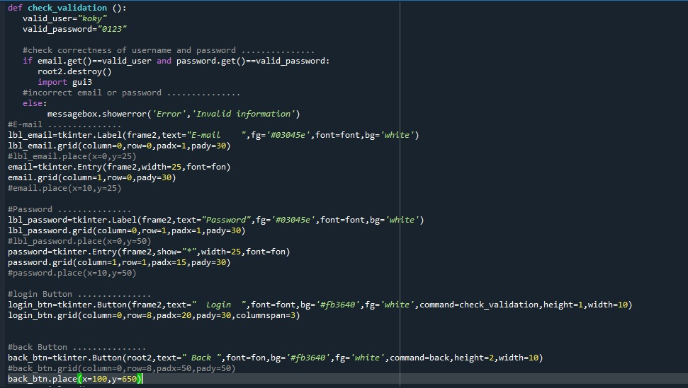

**In the third frame:**

The assistant can specify the identity as “**Teacher** “

or as a “**Student**” to be able to enter their data.

**As shown in GUI 3.**

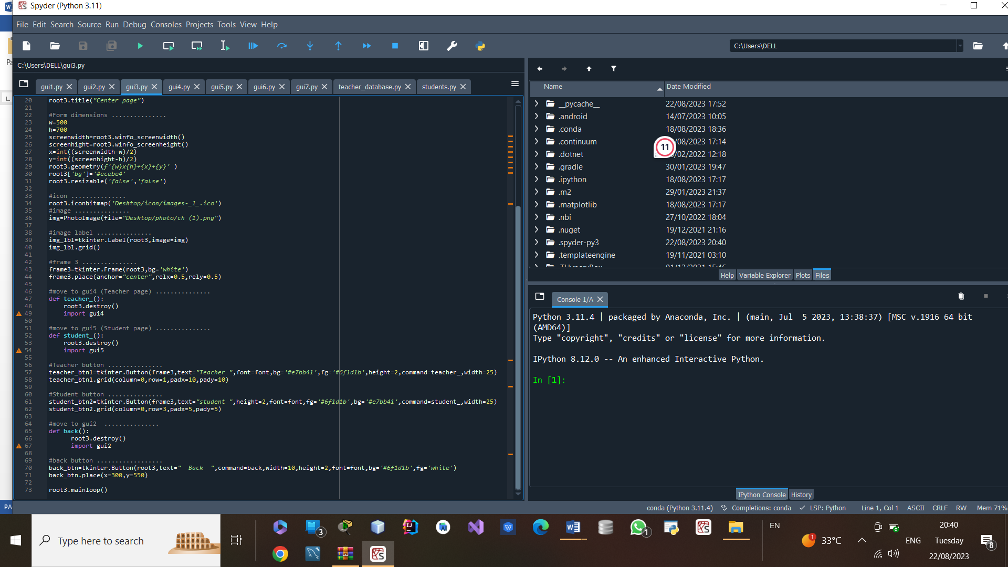

**In the fourth frame:**

**This frame is for teachers**, where the assistant enters his information as

* **name.**
* **age.**
* **phone number.**
* **Id.**
* **Gender “male or female”.**
* **Subject.**
* **Salary.**

**In this frame**, there are six buttons

* **Back.**
* **Add.**
* **Delete.**
* **Update.**
* **Search.**
* **Select all.**

These buttons make it easier for the assistant to choose the required information.

**As shown in GUI 4 .**

**In the fifth frame:**

This frame is for **students**, as it helps the assistant enter required data as

* **Name**
* **Age**
* **Academic year**
* **Id**
* **Gender “male or female”**
* **Subject**

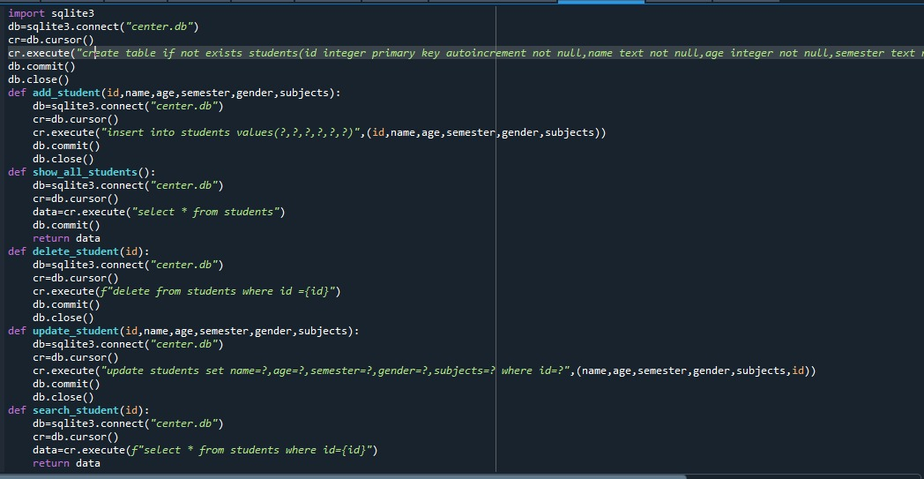

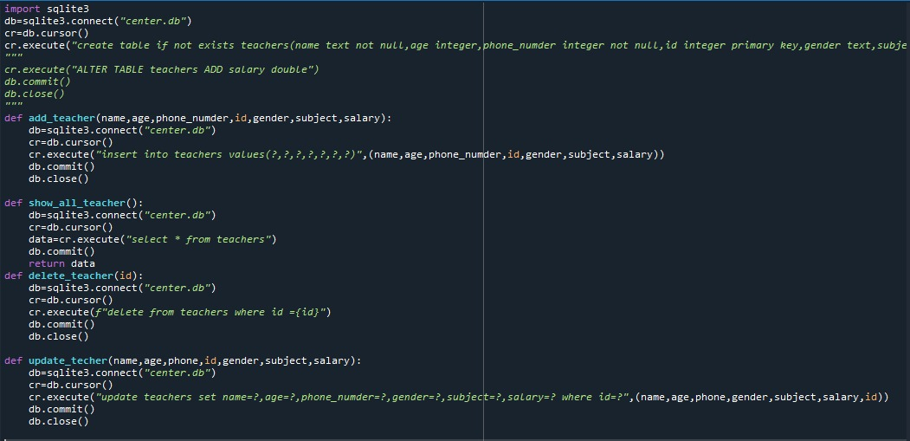

**In this frame there are six buttons**

* Back
* Add
* Delete
* Update
* Search
* Select all

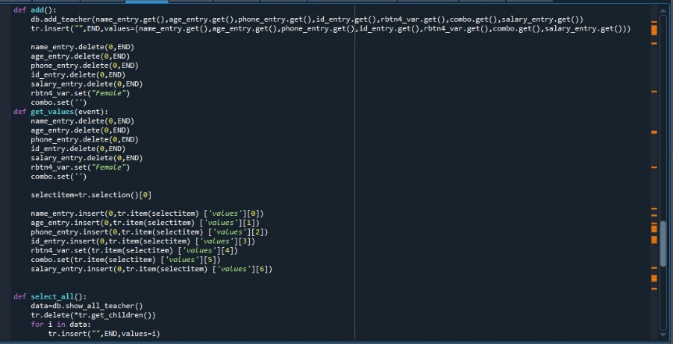

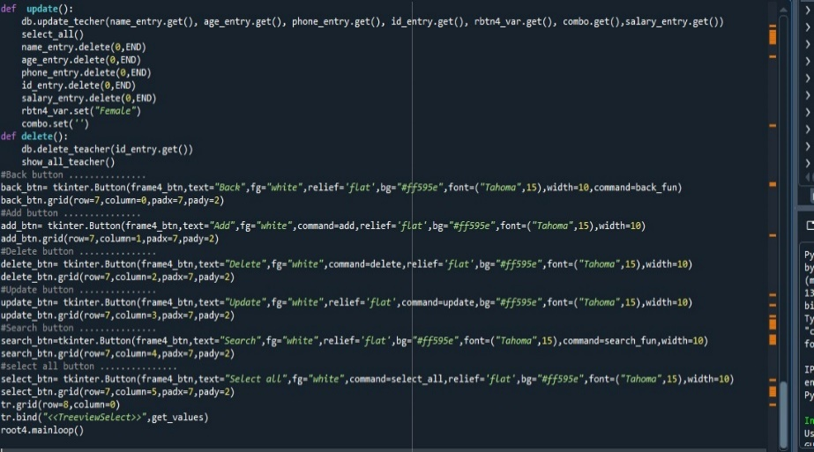

These buttons make it easier for the students to choose the required needs.

**As shown in GUI 5.**

**In the sixth frame:**

This frame is for the **student**, through which it is possible to **search** for any student and his information through the id

**As shown in GUI 6.**

**In the seventh frame:**

This framework is for the **teacher**, through which it is possible to **search** for any teacher and his information through the id

**As shown in GUI 7.**

**To build this system we use the following library.**

**ERD of project**

Name

Salary

Name

**ID**

Age

**ID**

Age

Phone number

Gender

Subject

Semester

Subject

Gender

Teacher

Teach

Student

**Mapping**

* **Student**

|  |  |  |  |  |  |
| --- | --- | --- | --- | --- | --- |
| name | Student_id | age | semester | gender | subject |

* **Teach**

|  |  |  |
| --- | --- | --- |
| Student_id | Teacher_id |  |

* **Teacher**

|  |  |  |  |  |  |  |
| --- | --- | --- | --- | --- | --- | --- |
| name | Teacher_id | age | Phone number | Salary | subject | gender |